**Aim: To develop and design a website for wayanad fund relief**

**Procedure:**

1.Choose a image and create a frame .

2.Add the tiltle and images into the frame .

3. Ensure details is encaptured within your created frames

4.  Add a payment page for paying donation.

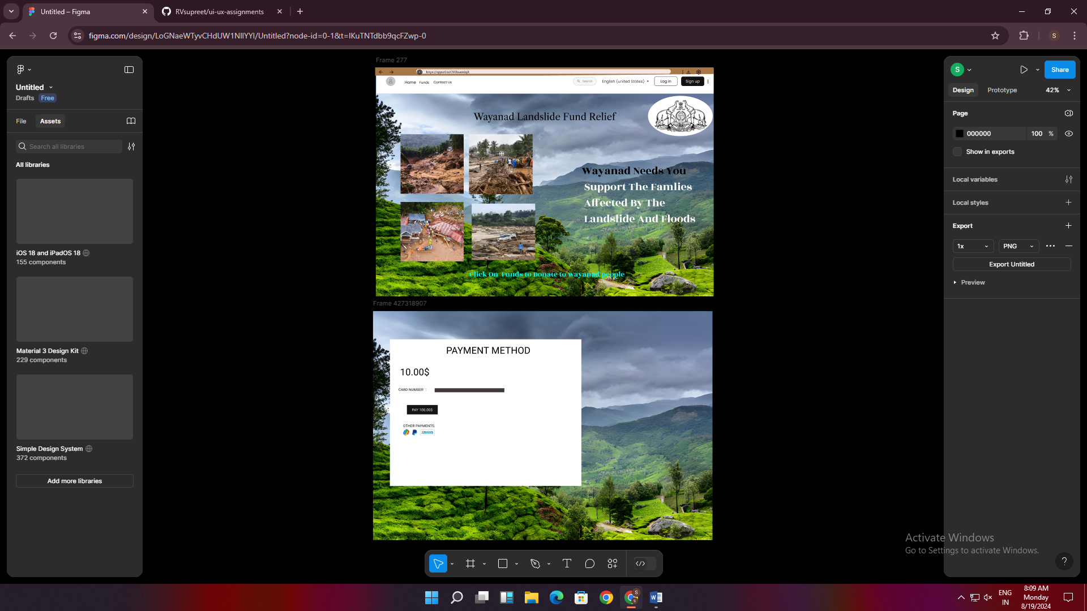

Result:

Thus the website has been designed for wayanad fund relief